UML Assignment 359861

Ricardo van der Heide

r.a.van.der.heide@st.hanze.nl

Activity Diagram

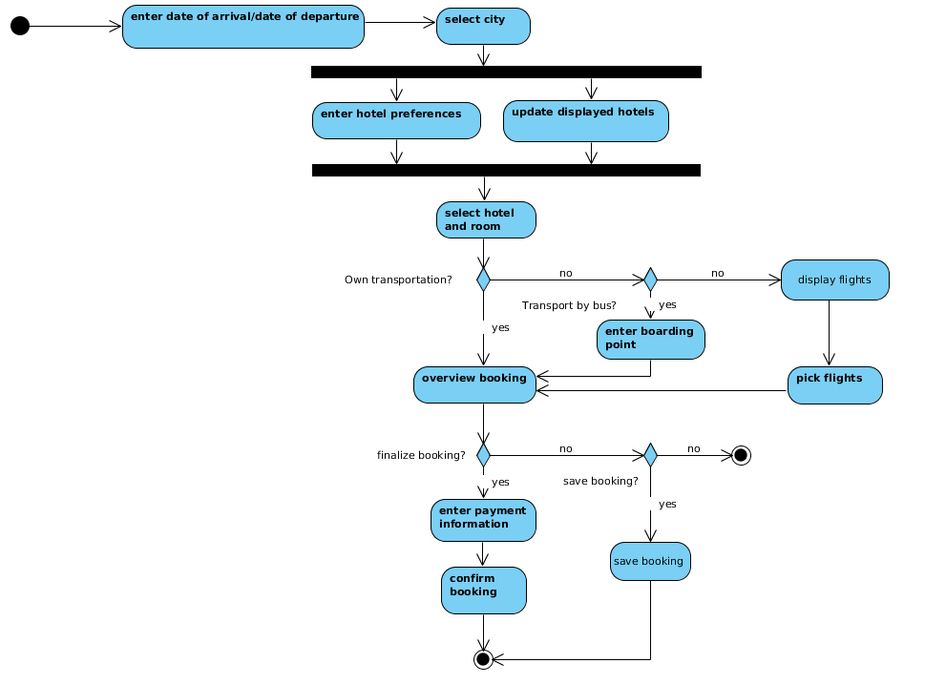

The user selects the data he/she wants to travel. Once he has done that, the user can select the city he wants to go to. After that, the user can select the requirements the hotel has to fulfill and this will automatically update the hotels displayed. Once the user has made a decision he selects the hotel and the room. After that the system will ask if the user wants to travel to the hotel with his own transportation. If he does, the user gets an overview of the booking. Then he can finalise the booking if he chooses to. If he doesn’t, he gets the option to save the booking or quit the booking process.  
If the user did finalize the booking, he can enter his payment information and the booking will be confirmed.

If the user chooses to not travel with his own transportation, he is asked if he wants to travel by bus. If so, he can choose the boarding point. Then the booking process resumes as previously described.

If he doesnt want to travel by bus, he has to travel by plane. The possible flights will then be shown on screen and he can book the plane ticket. Then the booking process resumes as previously described.

Use case diagram:

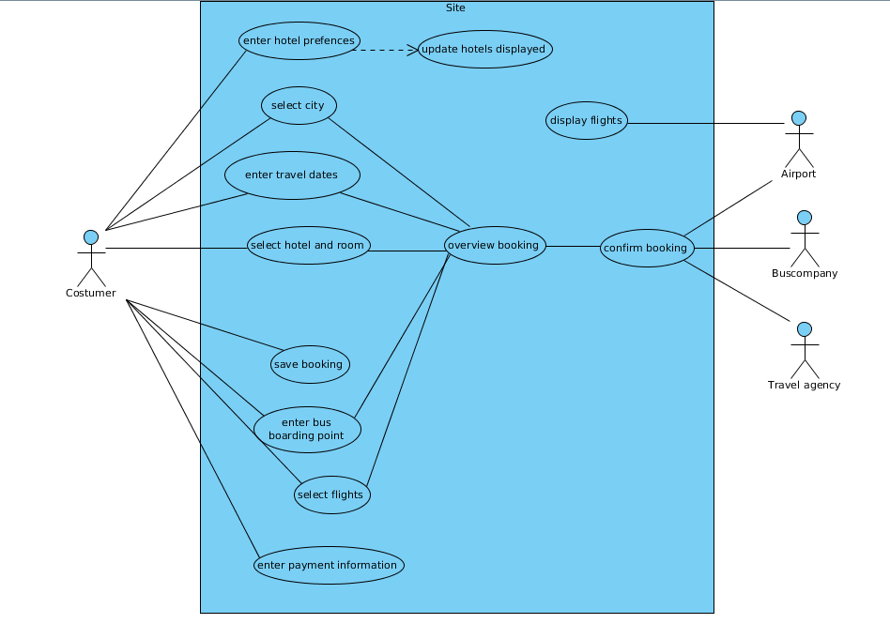

**Name use case**  Enter date of arrival and departure  
**Trigger** Customer decides to set the dates for his holiday  
**Actors** Customer

**Preconditions** The costumer is on the travel site  
**Goal**  The dates for the trip are known

**Basic course of actions** 1. The site displays two empty fields where the date of arrival and date of departure are going to be displayed.  
 2. The customer selects the field with the date of arrival 3. The site shows a calendar 4. The customer selects the date of arrival 5. The site now displays the date of arrival but not yet the date of departure 6. The customer selects the field with date of departure 7. The site now shows a calendar 8. The customer selects the date of departure 9. The site displays the dates of arrival and departure 10. The customer clicks the ‘confirm’button to confirm the dates

**Failed conclusion** The dates have not been set, booking process does not yet continue  
**Post conditions**  The dates of travel have been set

**Name use case** Select city **Trigger** Customer has set dates and continues booking process **Actors** Customer

**Preconditions** Customer has selected the dates for his travels **Goal** The costumer has successfully selected the city he wants to travel to

**Basic course of actions** 1. The site displays pictures with all the cities he can choose from  
 2. The customer selects the city he wants to travel to  
 3. The site displays the cities the customer can choose from, and the currently selected city is highlighted  
 4. The customer confirms his selecting by pressing the ‘confirm’ button

**Failed conclusion** The customer has not selected a city and can’t continue with the booking process until he does **Post conditions** The customer has confirmed the city he wants to travel to

--------------------------------------------------------------------------------------------------------------------------------------

**Name use case** Enter hotel preferences **Trigger** The customer wants to continue booking process **Actors** Customer

**Preconditions** The city the customer wants to travel to has been set **Goal** Display all the hotels that meet the customer’s requirements

**Basic course of actions** 1. The site shows all the requirements the customer can choose from 2. The customer selects all the requirements he wants 3. The customer clicks the ‘update’ button 4. <<include use case *update displayed hotels*>> 5. The site displays hotels that meet the requirements

**Failed conclusion** - **Post conditions** The site displays all the hotels that meet the customer’s requirements

**Name use case** Update displayed hotels **Trigger** Customer has selected his requirements and pressed ‘update’ **Actors** System

**Preconditions** Customer has selected the requirements the hotel has to meet **Goal** Only showint the hotels that meet the requirements

**Basic course of actions** 1. Site checks database to filter out hotels that don’t meet the requirements the customer has set 2. Site displays only the hotels that meet the requirements

**Failed conclusion** None of the hotels meet the client’s requirements No hotels are shown **Post conditions** Hotels that meet the requirements are shown

**Name use case** Select hotel and room **Trigger** The customer has selected all the requirements his hotel has to meet and wants to select one **Actors** Customer

**Preconditions** Only hotels that fullfill the requirements are shown **Goal** The customer has selected and confirmed the hotel and room he wants to stay in

**Basic course of actions** 1. The site displays all hotels that meet the requirements 2. Customer selects the hotel he would like to stay in 3. Site displays all available rooms and costs 4. Customer selects the room he wants to stay in 5. The site asks for confirmation 6. The costumer clicks the ‘confirm’ button

**Failed conclusion** No free rooms available Select different hotel  **Post conditions** The customer has confirmed the room and hotel he wants to stay in

**Name use case** Overview booking **Trigger** The customer has confirmed his way of transportation **Actors** Customer

**Preconditions** The customer has selected his hotel and room, and has selected his way of transportation to said hotel **Goal** Give the customer an overview of all the things he has currently selected

**Basic course of actions** 1. Site displays all the information the customer has selected so far

**Failed conclusion** - **Post conditions** Site displays all the confirmed information the customer has selected

**Name use case** Display flight **Trigger** The customer did not want to be transported by bus **Actors** Airport

**Preconditions** The customer has selected hotel and room The customer has selected no to the question of own transportation The customer has selected no to the question of transport by bus **Goal** Display all flights that meet the travel dates of the customer

**Basic course of actions** 1. The site checks available flight times with the airport 2. The site displays all available flights for the arrival and departure date of the customer

**Failed conclusion** No flights available **Post conditions** The site displays all available flights for the set dates

**Name use case** Pick flight **Trigger** The site shows all available flights  **Actors** Customer

**Preconditions** There are available flights for the dates set by the customer **Goal** Confirming the flights the customer takes

**Basic course of actions** 1. The site displays all available flights and departure/arrival data for said flights 2. The customer selects the flight for arrival and departure 3. The site displays the options the customer has selected 4. The customer confirms the flight

**Failed conclusion** No flights have been selected, booking process pauses **Post conditions** The customer has confirmed the flight data

**Name use case** Enter boarding point **Trigger** The customer has selected yes to the question if he wants to travel by bus **Actors** Customer

**Preconditions** The customer choose not to travel by own transportation and choose travel by bus **Goal** The customer has booked his bus

**Basic course of actions** 1. The site displays all possible boarding points and times for the bus to and from his destination 2. The customer chooses the boarding point for his bus 3. The customer clicks the ‘confirm’button

**Failed conclusion** No boarding points have been selected, booking process pauses **Post conditions** The customer has confirmed his bus boarding time and point

**Name use case** Enter payment information **Trigger** User has overviewed the booking and choose to finalize it **Actors** User

**Preconditions** User has finalized booking  **Goal** Aquire payment information customer

**Basic course of actions** 1. Site shows the amount that has to be payed 2. Customer clicks ‘continue’ button 3. Site displays all payment options 4. User selects the payment option he wants to use 5. User clicks ‘continue’ button 6. Site shows the payment option and the fields to enter all necessary details 7. User enters payment details 8. User clicks ‘confirm payment details’button 9. Site shows that the payment has been processed

**Failed conclusion** Not enough money, abort booking process **Post conditions** The user’s payment details are in the system and the payment has been made.

**Name use case** Confirm booking **Trigger** Payment has been made **Actors** Travel agency, airport, bus company

**Preconditions** Booking has been succesfully paid **Goal** Complete booking by sending booking information over to the relevant actors

**Basic course of actions** 1. The relevant companies recieve the booking 2. Site shows the page that informs the customer that the booking has been completed

**Failed conclusion** Something has gone wrong while sending the booking over, call travel agency **Post conditions** The booking has been processed and completed

**Name use case** save booking  **Trigger** The customer chose to save the booking **Actors** Customer

**Preconditions** The customer did not want to finalize the booking and in stead decided to save the booking **Goal** Save the booking

**Basic course of actions** 1. The site shows all data that’s going to be saved 2. The customer clicks the ‘save’ button 3. The site stores the data in the database 4. The site gives the consumer a link to the page where the data is saved

**Failed conclusion** Couldn’t save the data, please call the travel agency **Post conditions** The booking has been saved for later acces